Project Summary Report: NZ Equine Trust –Racing Injury

25 January 2023
Prof Chris Rogers ^{1,2}
Co Investigators: Assoc Prof Erica Gee¹, Prof Keren Dittmer¹, Dr Michaela Gibson¹, Ms Kylie Legg
School of Veterinary Science, School of Agriculture and Environment
Massey University

Significant progress has been made with this project retrieving limbs for race-day fractures. We now have a robust system for the post-mortem service for horses in the lower North Island with good coordination between the Stipendiary Stewards, the Equine Ambulance crew and Massey University. The team in the South Island, particularly the lower South Island have been very good in couriering up limbs from horse involved in race day fatalities. There are still some logistical difficulties with the obtaining of limbs from the track in the upper North Island and much of this is the limitation in availability of suitable areas for race day veterinarians to disarticulate limbs. It is anticipated that the establishment of a cremation service in the Auckland region may provide an option for access to limbs from horses involved in race day fatalities in the upper North Island. To date we have collected limbs and imaging data from 18 race day fatalities and 20 control horses. We are currently completing a descriptive paper on the cases obtained to date. The majority of fractures were in the forelimb (86%), with a slight bias towards fracture of the left forelimb (55%). There were 2 fracture involving the humerus, with the remaining fractures involving the metacarpus/ metatarsus (75% of these were condylar fractures) or the first phalanx (16%). We currently have a manuscript in preparation describing the characteristics (pQCT, gross morphology and histology) of race day fracture in New Zealand.
The low prevalence of race day fatality is a very interesting and positive story for the New Zealand racing industry. However, it does provide a limitation in the quantity of post mortem material we have access to. Within this project we have examined the historical trend of this low fracture prevalence over the last 16 years. The interesting finding with this work has been that with increasing rigor in the documentation of race day fatalities, and implementation of the international rule for inclusion of horses that die or are euthanised with 72 hours of completing a race, we have not observed a change in the frequency of fracture reporting, just better description of the reason for the fatality [1-3]. This is a beneficial story for the industry and reinforces that we have a racing industry with a consistently low rate of injury and fatality. We have also examined the impact of the Covid19 lockdown and associated cessation of racing on the pattern of race day injuries in both Harness and flat racing in New Zealand. There was a post-lockdown rebound in the number of horses racing, but no change in the incidence or type of injuries reported. This data demonstrated that the industry, and the trainers in particular, did a great job in responding to the interruption in training and racing.
In New Zealand we are fortunate to have a breeding industry that provides a rearing environment that promotes positive growth and development of the equine athlete. This may be a contributing factor to the low level of race day fatality and within this project we have attempted to document this via a series of reviews on growth and development of the equine athlete [4-6]. More recently we have attempted to unbundle the interaction of the pattern of racing and training on race day fatality [7]. We have subsequently expanded this concept to propose that this pattern is not just constrained by biology but is influenced by the sociology and economics of each racing jurisdiction. The summary of this preliminary examination of the bioeconomic model has just recently been published [8].
Conclusion:
The project has managed to provide some valuable data for the New Zealand Racing industry. The industry has a low incidence of race day fracture and fatality. The ability to monitor the changes in reporting process over the years with no change in the incidence reinforces the integrity of the New Zealand racing industry. The greater level of detail reported with the recent changes will greatly aid future research and the ability to make meaningful changes in practice. The bioeconomic model work has highlighted the need to consider the production system when examining risk factors and reasons for exit from the industry. New Zealand is fortunate to have a rearing environment second to none, and the pattern of racing appears to be protective from a horse welfare point of view. A summary of many of these points were presented to presented to race day and equine veterinarians in 2022 and is provided as an appendix to this final report.

References:

1. Gibson, M.J.; Bolwell, C.F.; Gee, E.K.; Legg, K.A.; Rogers, C.W. Race-Level Reporting of Incidents during Two Seasons (2015/16 to 2016/17) of Thoroughbred Flat Racing in New Zealand. Animals 2022, 12, 1033.
2. Gibson, M.J.; Legg, K.A.; Gee, E.K.; Rogers, C.W. Race-level reporting of incidents using an app-based system during three seasons (2019/2020-2021/2022) of Thoroughbred flat racing in New Zealand. Animals 2022.
3. Gibson, M.J.; Roca Fraga, F.J.; Bolwell, C.F.; Gee, E.K.; Rogers, C.W. Race-Level Reporting of Incidents during Two Seasons (2015/16 to 2016/17) of Harness Racing in New Zealand. Animals 2022, 12, 433.
4. Rogers, C.W.; Dittmer, K.E. Does Juvenile Play Programme the Equine Musculoskeletal System? Animals 2019, 9, 646, doi:https://doi.org/10.3390/ani9090646.
5. Rogers, C.W.; Bolwell, C.F.; Gee, E.K.; Rosanowski, S.M. Equine musculoskeletal development and performance: impact of the production system and early training. Animal Production Science 2020, 60, 2169-2079, doi:https://doi.org/10.1071/AN17685.
6. Rogers, C.W.; Gee, E.K.; Dittmer, K.E. Growth and Bone Development in the Horse: When Is a Horse Skeletally Mature? Animals 2021, 11, 3402.
7. Legg, K.A.; Gee, E.K.; Cochrane, D.J.; Rogers, C.W. Preliminary Examination of the Biological and Industry Constraints on the Structure and Pattern of Thoroughbred Racing in New Zealand over Thirteen Seasons: 2005/06–2017/18. Animals 2021, 11, 2807.
8. Legg, K. A., Gee, E. K., Breheny, M., Gibson, M. J., & Rogers, C. W. (2023). A Bioeconomic Model for the Thoroughbred Racing Industry—Optimisation of the Production Cycle with a Horse Centric Welfare Perspective. Animals, 13(3), 479.

Appendix 1: Summary article provided to race day and equine veterinarians summarising the project to date – distributed winter 2022

Understanding racehorse fractures in New Zealand: A summary of recent research

Race day veterinarians play an important role in generating data that has helped describe race day injury patterns and race day fracture rates within New Zealand. This report summarises recent work originating from Massey University focusing on race day injury and fracture rates.

Across all racing jurisdictions there is considerable focus on identification of risk factors for race day fractures and methods to reduce the risk of race day fracture. The team at Massey University have been working on projects relating to race day injury and race day fracture for over 10 years. This document summarises some of the recent research outputs and findings from this research theme. Much of the recent research is published in open-access journals, so these papers are freely available for viewing (click on DOIs).

Impact of early growth and development
Raceday fractures represent the cumulative effect of the horse’s lifetime experiences. Some of these experiences have a relatively short temporal frame of reference and relate to loading during the race day preparation or recent training load, and others relate to the early priming of the musculoskeletal system early in life. Interestingly, from work in another species, looking at humerus fracture in first lactation dairy heifers, we have identified that challenges early in life not only alter the morphology of some bones, but may alter the magnitude and direction of response when provided with challenges later in life (Wehrle-Martinez – unpublished data). These data emphasise the importance of the early work by the team at Massey that demonstrated the positive effect early exercise had on the response of the horse to race day training [8-11].
Gibson, M., Dittmer, K., Hickson, R., Back, P., & Rogers, C. (2020). Bone Morphology and Strength in the Mid-Diaphysis of the Humerus and Metacarpus in Dairy Calves Prior to Weaning. Animals, 10(8), 1422. https://doi.org/10.3390/ani10081422
Gibson, M. J., Rogers, C. W., Pettigrew, E. J., Pain, S. J., Dittmer, K. E., Herath, H. M. G. P., & Back, P. J. (2022). The Effect of Artificial Rearing on Live Weight Gain and Bone Morphology of the Tibia in Lambs Prior to Weaning. Ruminants, 2(1), 101-111. https://doi.org/10.3390/ruminants2010006
To further understand how the early experiences of the foal and the impact of early exercise under conventional New Zealand management systems we examined the impact foal activity (play behaviour) on bone growth and development. Using published data from previous studies by our group [12,13]and within the literature we were able to model the load cycles within the distal limb. This demonstrated the tight positive relationship between normal foal play and stimulation of the musculoskeletal system.
Rogers, C. W., & Dittmer, K. E. (2019). Does Juvenile Play Programme the Equine Musculoskeletal System? Animals, 9(9), 646. https://doi.org/10.3390/ani9090646
2-year-old racing
Within the popular press and amongst groups antagonistic towards horse racing there is a common theme that racing 2-year-olds is detrimental. The predominant suggestion is that a race horses long term health is compromised due to their immaturity at the time of starting training. This is an interesting observation, given the large level of peer reviewed evidence, much originating from Massey University, that has demonstrated that early exercise, and 2-year-old training has positive effects on the musculoskeletal system and career length and success [14,15]. Our group conducted a review of growth plate closure in the horse and related growth in the horse to measures of skeletal maturity with the human literature. Using weighted estimates based on published data we were able to demonstrate that irrespective of breed, by 24 months of age horses had achieved all the measures of skeletal maturity commonly used within the human literature.
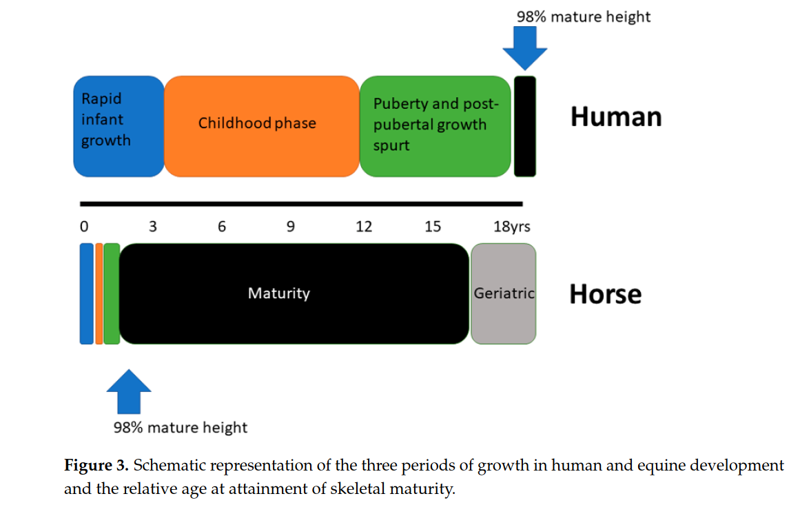
Rogers, C. W., Gee, E. K., & Dittmer, K. E. (2021). Growth and Bone Development in the Horse: When Is a Horse Skeletally Mature? Animals, 11(12), 3402. https://doi.org/10.3390/ani11123402
To provide a synthesis of the impact of early exercise, including 2-year-old racing on musculoskeletal health we collated much of our previous work and those of colleagues in an open access review within Animal Production Science. This publication provided a widely available summary of current knowledge.
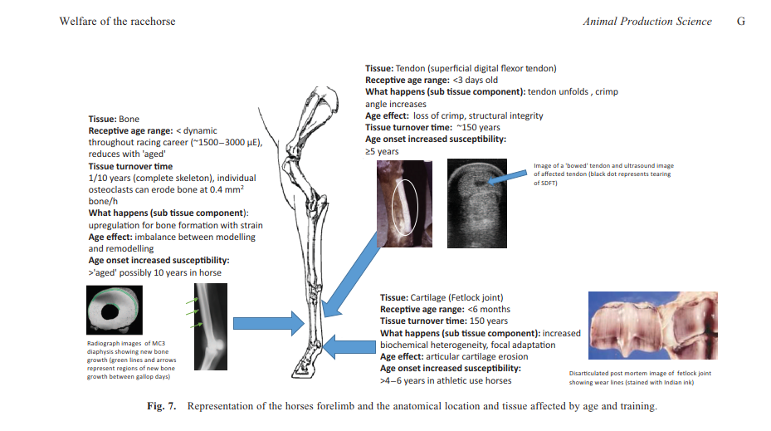
Rogers, C. W., Bolwell, C. F., Gee, E. K., & Rosanowski, S. M. (2020). Equine musculoskeletal development and performance: impact of the production system and early training. Animal Production Science, 60(18), 2169-2079. https://doi.org/10.1071/AN17685

Race day injury and fracture
In New Zealand race day injury data are available via the official publication of the stipendiary stewards’ reports. Prior to the use of the online system data had to be manually transcribed from the reports into a database for subsequent analysis. This was a time-consuming process and the nature of the free text entries within the stewards’ reports had the potential for horse names, etc to be misspelt and for a large variation in the terms and phrases used to describe the injury and the anatomical location. These errors required a large amount of time to check errors and recode data, and meant some records were unusable. To date we have examined the race day injuring data from the last 2 years (for both Harness and Thoroughbred racing) when this paper system was in operation. The findings from these studies supported the earlier work on the low frequency of race day fractures in New Zealand [16,17]. We currently have a manuscript under review describing the first 2 years of the online reporting system within the harness racing industry. The results demonstrated a large improvement in data quality and no significant differences in the rates of injuries reported. This is an important finding as it shows the harness racing industry has a low race day injury rate and that the Covid-19 lockdown did not alter the pattern of race day injury. We will examine three full seasons of online reporting within the Thoroughbred industry at the completion of the current racing season 2021/22.
Gibson, M. J., Roca Fraga, F. J., Bolwell, C. F., Gee, E. K., & Rogers, C. W. (2022). Race-Level Reporting of Incidents during Two Seasons (2015/16 to 2016/17) of Harness Racing in New Zealand. Animals, 12(4), 433. https://doi.org/10.3390/ani12040433
Gibson, M. J., Bolwell, C. F., Gee, E. K., Legg, K. A., & Rogers, C. W. (2022). Race-Level Reporting of Incidents during Two Seasons (2015/16 to 2016/17) of Thoroughbred Flat Racing in New Zealand. Animals, 12(8), 1033. https://doi.org/10.3390/ani12081033

Pattern of racing and injury rate and fracture risk
There is an increasingly strong body of evidence to support the hypothesis that fracture risk may be racing jurisdiction specific [18,19]. New Zealand has a low rate of race day fracture [16,17] and this may be a reflection of the racing and training pattern and the age profile of our racing population. To collate these metrics and to start to answer this question of how these differ to other racing jurisdictions we have examined the pattern of racing and industry structure of Thoroughbred racing over the last 13 seasons. These data showed the contracting foal crop and a consistent level of exports have resulted in an industry with more fillies racing and an increasing age profile to provide a similar number of race day starters. An interesting finding in relation to decreasing fracture risk was the decreasing length of spells, which is a similar pattern to that observed in Australia.
Legg, K. A., Gee, E. K., Cochrane, D. J., & Rogers, C. W. (2021). Preliminary Examination of the Biological and Industry Constraints on the Structure and Pattern of Thoroughbred Racing in New Zealand over Thirteen Seasons: 2005/06–2017/18. Animals, 11(10), 2807., https://doi.org/10.3390/ani11102807

Pathology of race day fractures
The low incidence of race day fractures is a positive for the industry but does mean that the collation of sufficient material for meaningful reporting of fracture pathology will take several seasons. There is also the need to be able to relate findings in fracture limbs and horses back to non-affected horses. In an ideal world it would be great to expand the programme to collect data from all horses that suffer a catastrophic fracture, including those occurring during training. However, this is a difficult task to manage at a national level. The collection of appropriate post mortem material is a time-consuming process. However, we are fortunate that we do have some data available from earlier observation and intervention trials [20-23]. At the completion of the 2022/2023 racing season we should have sufficient post-mortem material to present some preliminary findings.

Future direction:
Our data have demonstrated that New Zealand racing has a low incidence of fractures and catastrophic musculoskeletal injury. This information is useful to demonstrate the robustness of current screening and management strategies. The increasing awareness of distinct differences in racing jurisdictions in fracture risk and risk factors means we need New Zealand based data. There is no single “risk factor” for fracture and the current data supports a multipronged approach to identify practices to reduce fracture risk:
- can we modify the early management environment to “prime” the musculoskeletal system improve how it reacts to race training?
- how does the pattern of racing and training in New Zealand relate to fracture risk? We require a (bio-economic) model in which we can test the impact of changes to the structure of training and racing.
- Ongoing post mortem analysis to improve our understanding of the musculoskeletal response to training and racing within the New Zealand racing environment

References:

1. Firth, E.C.; Rogers, C.W.; van Weeren, P.R.; Barneveld, A.; Kawcak, C.E.; McIlwraith, C.W.; Goodship, A.E.; Smith, R.K.W. Exercise imposed in early life is associated with altered bone tissue responses to later training. In Proceedings of the Proceedings of the 6th World Congress on Developmental Origins of Health and Disease, Santiago, Chile, 2009.
2. Firth, E.C.; Rogers, C.W.; van Weeren, P.R.; Barneveld, A.; Kawcak, C.E.; McIlwraith, C.W.; Goodship, A.E.; Smith, R.K.w. Changes in diaphyseal and epiphyseal bone parameters in Thoroughbred horses after withdrawal from training. In Proceedings of the Proceddings of the International Society of Musculoskeletal and Neuronal Interactions Forum. Germany, Black Forest, Germany, 2006.
3. Rogers, C.W.; Firth, E.C.; McIlwraith, C.W.; Barneveld, A.; Goodship, A.E.; Kawcak, C.E.; Smith, R.K.W.; van Weeren, P.R. Evaluation of a new strategy to modulate skeletal development in racehorses by imposing track-based exercise during growth: The effects on 2-and 3-year-old racing careers. Equine Veterinary Journal 2008, 40, 119-127.
4. Rogers, C.W.; Firth, E.C.; McIlwraitth, C.W.; Barneveld, A.; Goodship, A.E.; Kawcak, C.E.; Smith, R.K.W.; van Weeren, P.R. Evaluation of a new strategy to modulate skeletal development in Thoroughbred performance horses by imposing track-based exercise during growth. Equine Veterinary Journal 2008, 40, 111-118.
5. Kurvers, C.M.H.C.; van Weeren, P.R.; Rogers, C.W.; van Dierendonck, M.C. Quantification of spontaneous locomotion activity in foals kept in pastures under various management conditions. American Journal of Veterinary Research 2006, 67, 1212-1217.
6. Rogers, C.W.; Bolwell, C.F.; Gee, E.K. Proactive management of the equine athlete. Animals 2012, 2, 640-655, doi:doi:10.3390/ani2040640.
7. Tanner, J.C.; Rogers, C.W.; Firth, E.C. The relationship of training milestones with racing success in a population of Standardbred horses in New Zealand. New Zealand Veterinary Journal 2011, 59, 323-327, doi:10.1080/00480169.2011.617029.
8. Tanner, J.C.; Rogers, C.W.; Firth, E.C. The association of 2-year-old training milestones with career length and racing success in a sample of Thoroughbred horses in New Zealand. Equine Veterinary Journal 2013, 45, 20-24.
9. Tanner, J.C.; Rogers, C.W.; Bolwell, C.F.; Cogger, N.; Gee, E.K.; McIlwraith, C.W. Analysis of Failure to Finish a Race in a Cohort of Thoroughbred Racehorses in New Zealand. Animals 2016, 6, doi:10.3390/ani6060036, doi:doi:10.3390/ani6060036.
10. Bolwell, C.; Rogers, C.; Gee, E.; McIlwraith, W. Epidemiology of Musculoskeletal Injury during Racing on New Zealand Racetracks 2005-2011. Animals : an open access journal from MDPI 2017, 7, doi:10.3390/ani7080062.
11. Morrice-West, A. An investigation of training and racing workloads in thoroughbred racehorses in Australia and their relationship to performance and bone fatique. University of Melbourne, 2020.
12. Hitchens, P.L.; Morrice-West, A.V.; Stevenson, M.A.; Whitton, R.C. Meta-analysis of risk factors for racehorse catastrophic musculoskeletal injury in flat racing. The Veterinary Journal 2019, 245, 29-40, doi:https://doi.org/10.1016/j.tvjl.2018.11.014.
13. Bogers, S.H.; Rogers, C.W.; Bolwell, C.; Roe, W.D.; Gee, E.K.; McIlwraith, C.W. Quantitative comparison of the bone mineral density characteristics of third metacarpal distal epiphyses with and without condylar fracture. American Journal of Veterinary Research 2016, 77, 32-98.
14. Bogers, S.H.; Rogers, C.W.; Bolwell, C.F.; Roe, W.D.; Gee, E.K.; McIlwraith, C.W. The effect of 2-year-old race training on BMDv and its spatial distribution in the distal epiphyisis of the third metatarsal bone. The Veterinary Journal 2014, 201, 353-358.
15. Firth, E.C.; Rogers, C.W.; Doube, M.; Jopson, N.B. Musculoskeletal responses of 2-year-old Thoroughbred horses to early training. 6. Bone parameters in the third metacarpal and third metatarsal bones. New Zealand Veterinary Journal 2005, 53, 101-112.
16. Legg, K.A.; Colborne, G.R.; Gee, E.K.; Rogers, C.W. Elastic properties of collateral and sesamoid ligaments in the forelimbs of equine cadavers. American journal of veterinary research 2019, 80, 923-930.

